

FY B.Tech SEM I 2021-22

Engineering Physics Lab Course

# Experiment No: 7

**Title: Energy Bandgap of Semiconductor**

**Name:** Eshan Kalp Trivedi

**Roll No:** 16010221038

**Branch:** ETRX

**Batch:** D – 2

## Aim:

To Determine Energy Band Gap of Semiconductor.

## Theory:

In the case of insulators, the region between highest level of completely filled valence band and the lowest level of allowed conduction band is very wide. This is called energy gap, denoted by Eg and is about 3 eV to 7 eV in case of insulators. In case of semiconductors, this energy gap is quite small. For example, in case of germanium, Eg =0.7 eV and in case of silicon Eg =1.1 eV. In semiconductors at low temperatures, there are few charges carriers to move so conductivity is quite low. At higher temperatures, the donor or acceptor levels come in to action and provide charge carriers and hence the conduction increases.

In addition to the dependence of the electrical conductivity on the number of free charges, it also depends on their mobility. However, mobility of the charge carriers somewhat Decrease with increasing temperature but on the average the conductivity of the semiconductors rises with increasing temperature. To determine the energy gap of a semi-conducting material, we study the variation of its conductance with temperature. In reverse bias, the currents flowing through the junction are quite small and internal heating of the junction does not take place.

In the reverse bias, the saturated value of the reverse current for a PN junction diode is given by,

Is =A.T3/2 e -Eg/KT (1)

where,

A= constant term

Is = saturation current in micro ampere

T = temperature of junction diode in Kelvin

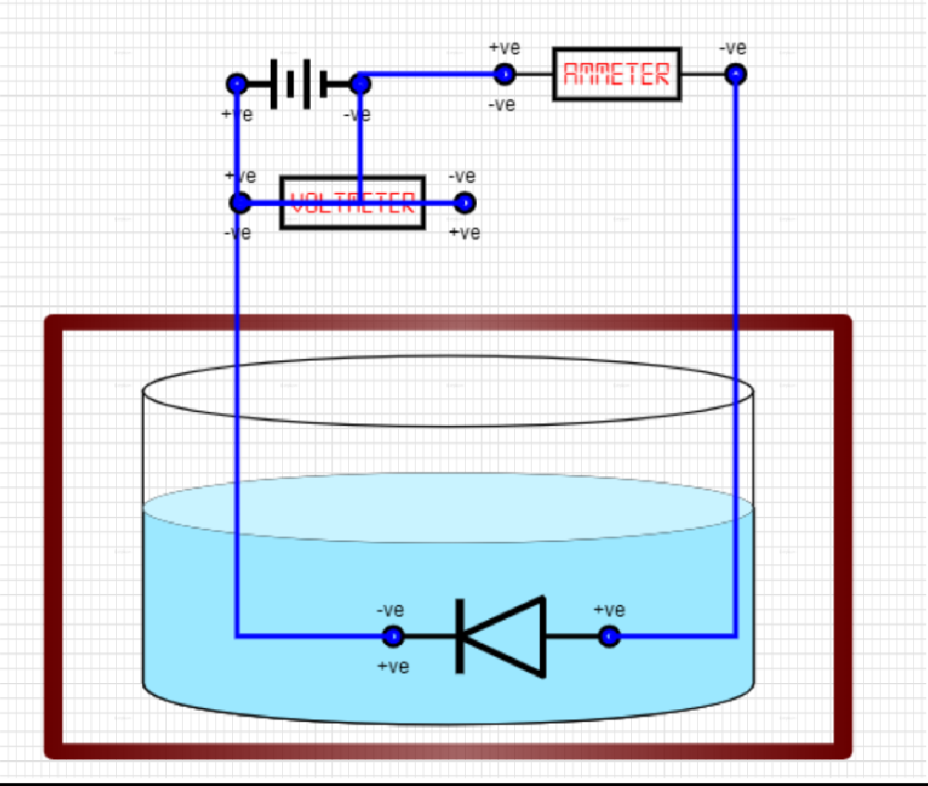

Eg = band gap in eV

K = Boltzmann constant in eV per Kelvin

For small changes in temperature where log T can be treated as constant relation (1) can be written as

log10Is = constant – 5.04 Eg. 103 /T (2)

Graph between 103 /T as abscissa and log10Is as ordinate will be a straight line having a slope

= 5.04Eg

Hence band gap

Eg = slope of the line / 5.04

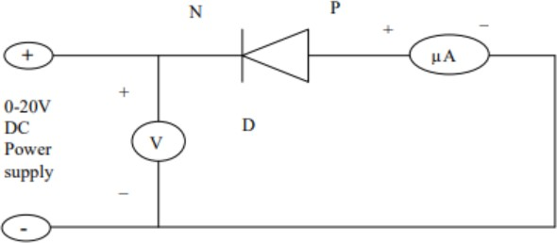

## Screenshot of Experimental setup:

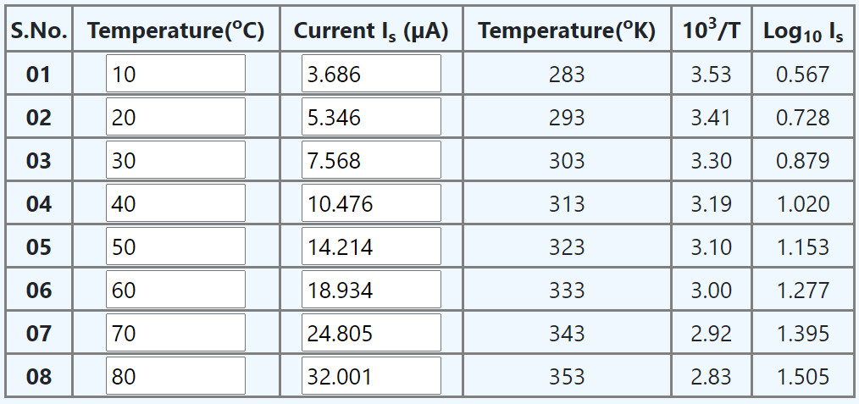

**Procedure:**

1. Click the “Enable Power” button.
2. Choose the correct image.
3. Click the “Place Container” button and then click on the drawing box.
4. Click on “Battery” button and then click to drawing box.
5. Click on “Ammeter” button and then click on drawing box.
6. Click on “Voltmeter” button and then click on drawing box.
7. Click on “PN Junction” button and then click on liquid inside container.
8. Click on “Connect” button and then click on point to be connected to complete the circuit diagram.
9. Select voltage from the drop down button.
10. After selecting voltage press the “Click” button.
11. Draw the slider to choose temperature.
12. Click on “Find here” button to get reverse saturation current.
13. Repeat this process to complete the observation table.
14. Click “Calculate Data” button.
15. Click on “Draw Graph” button.
16. Place the cursor on the plotted graph to enter the value of first and second coordinate.
17. Click on “Find Slope” button.
18. Click “Calculate” button to get the value of Energy Band Gap.

## Observation Table:

Voltage selected = 3V

## Graph:

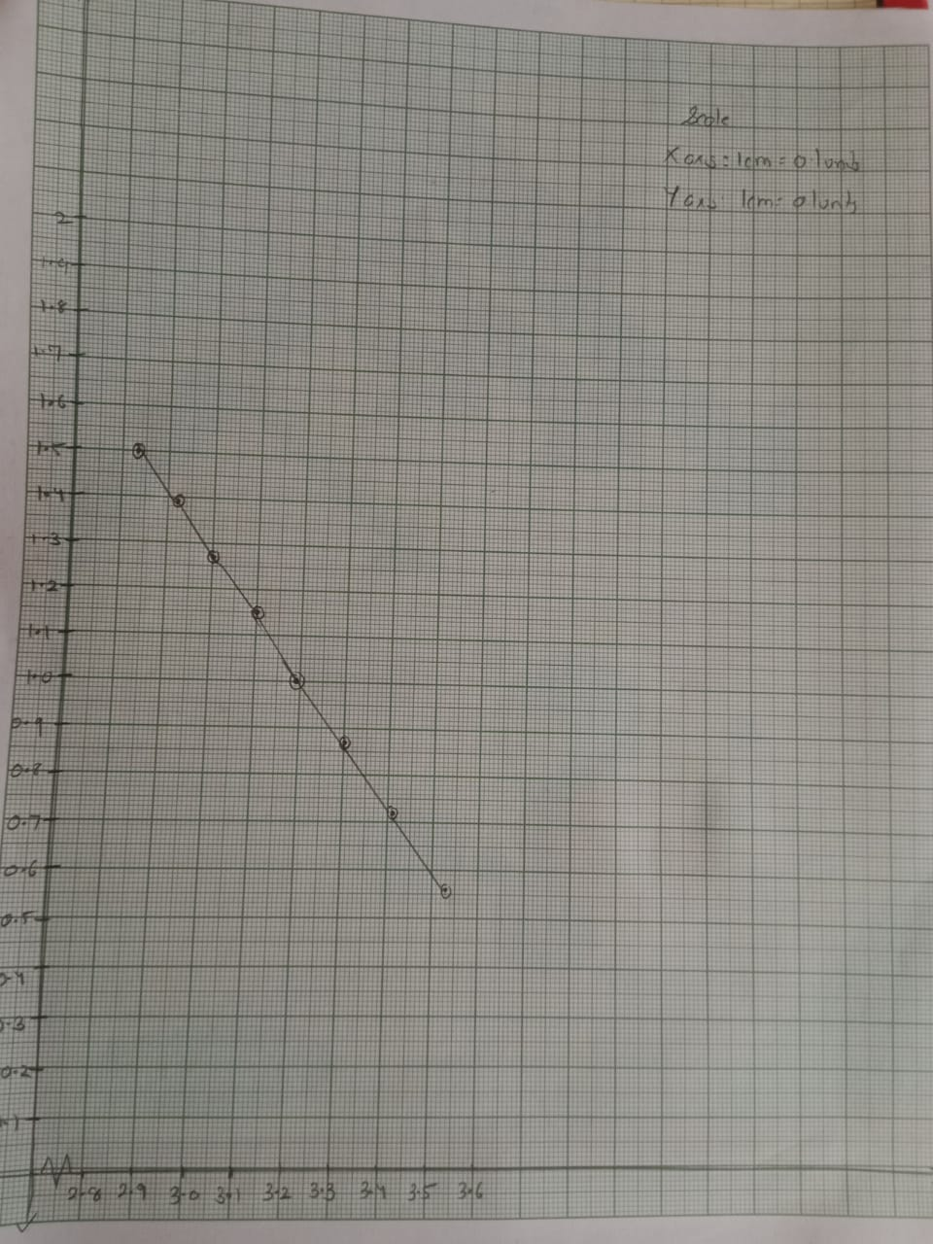



**Calculations:**

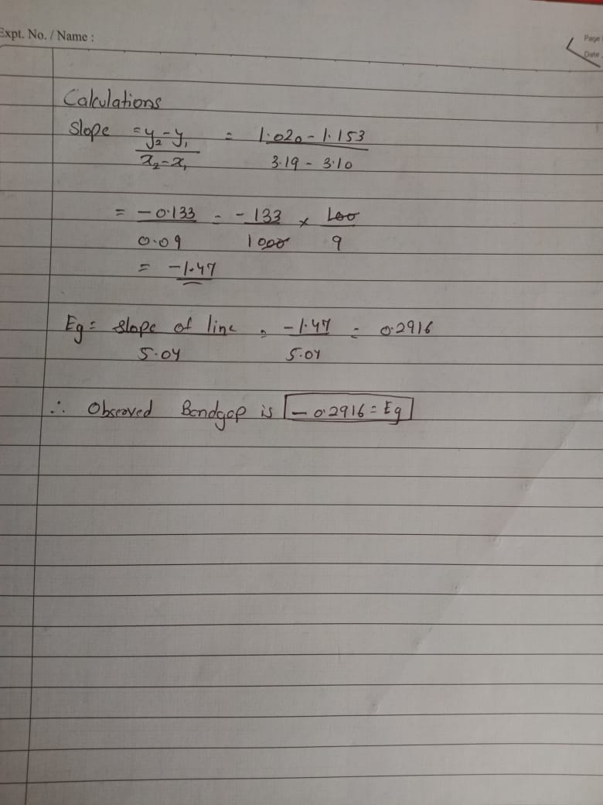

**Results and Conclusion:**

Thus, We have successfully verified and calculated the value of Energy Bandgap i.e.

**Eg= -0.2916**